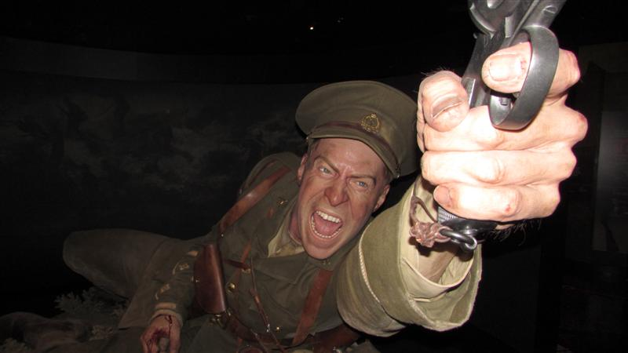
A special day at Te Papa for Hawkes Bay’s
Disability Resource Centre

Te Papa welcomed visitors from Hawkes Bay’s Disability Resource Centre over the weekend, who came to see the museum’s ground-breaking exhibition Gallipoli: The scale of our war.

The group from across Hawkes Bay marvelled at the giant figures, two and a half times life size, which were made for the exhibition by Weta Workshop.

Funding from the Masonic Trust provided transport to bring the group to Wellington, where Te Papa staff ensured they saw the best the national museum has to offer.

Disability Resource Centre (HB) Trust spokeswoman Ali Shapland said the trip was a fantastic experience.

“It was a great chance for our clients to experience something completely different, and share an adventure in the city while still having their friends around them.”

“Leaving Hastings at 6.45am and arriving back at 8pm it was a long day, but the smiling faces told the story of how much everyone enjoyed the day.”

“They had a wonderful time, and some said they'd love to go back again and explore some more.”

Te Papa’s Gallipoli exhibition features eight larger-than-life figures of New Zealanders involved in Gallipoli.

Helen Rapana was particularly affected by the model of Lottie Le Gallais, a nurse who is shown in the exhibition receiving the news that her brother has been killed in action.

Geoffrey Edwards was among the visitors who got up close with the making of the exhibition, having a chance to feel the latex “skin” which the giant figures are made of.

The hyper-realistic figures are lifelike to the last detail, with the hairs on their skin painstakingly created by Weta Workshop’s artisans.

As well as the Gallipoli exhibition, the Hawkes Bay group visited other parts of Te Papa, marvelling at the huge screen showing Ruapehu erupting, and jumping up and down to test their strength on the earthquake meter.

No trip to the capital is complete without stopping for a coffee, and the group enjoyed a cuppa at the Te Papa café before heading back to the Bay.

Media contact: Kate Camp, Te Papa, 029 601 0180
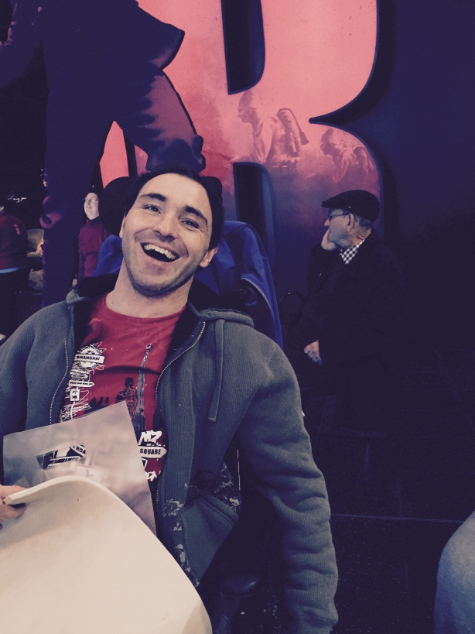

Photo caption

- Geoffrey Edwards at Te Papa’s exhibition Gallipoli: The scale of our war

